
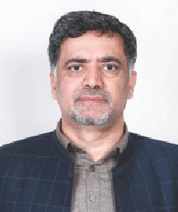
FAST-NUCES

Dean's Message
National University of Computer and Emerging Sciences stands among the top tier prestigious universities in Pakistan. As the Dean of Engineering, I am proud to say that our electrical engineering program is offered at alt five of our campuses, while the civil engineering program is exclusively available at our Lahore campus. Our engi n eeri ng p rogram s cate r to stu dents s pan ning Bach elor of Science (BS), Master of Science (MS), dnd Doctordte (Ph D) degrees.0 ur engineering programs are renowned for their excellence, thanks to our highly qualifi ed faculty members wh o are dedicated to providing students with the knowledge and skills they need to succeed in their careers. Our faculty members are experts in their fields and have extensive experience worki ng in industry and academia. They bring th i s we alth of k n ow ie d ge a n d ex p e r i e n c e to t h e c la s s ro o m, p r o v i d i n g s t u d e n t s w i I h a comprehensive education that is relevant to the needs of industry.
At National University of Computer dnd Emerging Sciences, we also place a strong emphasis on research. 0 u r we II- est a b lis h e d la b s a nd facilities provide our students with the opportunity to engage in cutting-edge resedrch and contribute to the ddvancement of their respective fields. We hdVe a strong culture of collaboration with universities dnd industries around the world, which allows our students and faculty members to exchange ideas, share

Prospectus 2025
Degree programs

Programs in Engineering

Dr Mukhtar Ullah
Professor and Dean (Engineering)
PhD (CS), University of Rostock, Germany (2009) PhD Approved Supervisor
MS (Controls), UMIST, UK (2002) BS (EE), UET, Peshawar (1999)

knowledge and work on projects of mutual interest.
Our engineering programs have been a c c r e d i t e d b y t h e P a k i s t an Engineering Council (PEC) and have a chi eve d Level- I I acc red itati o n under the Washington Accord. This recognition is a testament to the quality of our programs and the rigorous standards that we uphold. Our graduates are well-prepared to en te r th e wo rkfo rce a nd m a ke signifi cant co ntributtons to their respective fields. As a result, our alum ni are placed around the globe in reputed organizations such as Amazon, Vodafo ne, STC, Hu awie, Tarad ata, I BM, E m um ba, MansAl, Teradata, PLC, Schlumberger, MOL, Volvo, Samsung, Nokia and many others.
We are committed to providing our
sI u d e n ts w i I h d w o r I d - c I a s s educdtion thdt Wilt prepare them for successful careers and help them mdke a positive impact on society.


FAST-NUCES BS Programs in Engineering

BS Admission Test, Eligibility and Selection Criteria

Degrees | Computing  Bachelor of Science (Computer Engineering)
 | Bachelor of Science (Civil Engineering)
 | Bachelor of Science (Electrical Engineering)

Admission Applicant must select only one out of the Test three admission test options | FAST— NUCES
 | SAT
NTS NAT— IE
(NTS test[rom specific universities will not De
acceptable)

 |   1 | SSC (Matric) or an equivalent examination | 60% minimum marks
Eligibility | 2 | HSSC (FSc) or an equivalent examination | 60% minimum marks
 | 3 | Courses studies at HSSC or an equivalent level | Pre-Engg (Chemistry, Mathematics, Physics) OR ICS (Computer Science, Mathematics, Physics)

Selection Criteria | 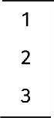  1  2  3 | Weightage of Ad mission Test marks | 33%
 |  | Weightage of HSSC/equivalent | 50%'
 |  | Weightage of SSC/equivalent | 17%
Engineering Domain
Pre-medical students who haVe pdSS9d ddditiondl mdths or they are wditing for results are eligible to apply for admission in engineering programs.
1Weightage of HSSC marks shall be calculated based on (whichever is applicable) at the time of compilation of merit list.
'Weightage of HSSC marks shall be calculated based on (whichever is applicable) at the time of compilation of merit list.
- Marks obtained in HSSC part I and II OR
- Marks obtained in HSSC part I, if result of HSSC part II not available OR
- Marks/ Percentage given in IBCC equivalence certificate of A-level OR
- Marks/ Percentage given in IBCC equivalence certificate of 0-level

Merit cut-off marks to be determined by the University
NOTE: All documents/transcripts will be checked at the time of admission. Any incorrect/false information submitted by the applicant or any attempt to hide information will lead to disqualification of the candidate for admission.

Prospectus 2025

FAST-NUCES
BS Programs in Engineering

Bachelor of Science (Computer Engineering)


Program Mission
The mission of the Department of Computer Engineering is:
To prepare competent Computer Engineering gradudtes conscious of professional ethiCdl and social responsibilities for productive engineering cdreers in industry acddem id and resed rch both lOCd lly d nd d brodd.
Program Educational

Objectives
The following Program Educational Objectives (PE0s) describe what the g r a d u a t e s o f I h e c o m p u t e r engineering program are expected to achieve withi n a few years after graduation:
- PEO1 Creativity: Apply cutting-edge engineering practices to develop sustainable solutions fo r c o m p I e x e n g i n e e r i n g p ro b ie m s, co n s i d e r i n g th e constraints of limited resources.
- P E 0 2 C o n d u c t: U p h o I d a responsible, professional, and e t h i c a I c o n d u c t w i I h interpersonal skills.
- PEO3 Leadership: Emerge as team leaders in their domain of expertise and in activities that support service and economic develops ent, n ation ally and throughout the world.
- PE 0 4 Ve rs ati I ity: P ra cti c e computer engineering in a broad r a n g e o f i n d u s t r i e s i n a m ulticultural environment and a d a p t t o e m b r a c e n e w tech nologies.

Career Opportunities
This versatile degree opens careers in d i fferent areas of Electrical Engineering. You could pursue a c a r e e r i n ie ie c o m i n d u s t ry, electronics, and power sector or in e m b ed d e d syste m d esign a nd software programming.

Prospectus 2025

Award of Degree
For the award of Bachelor of Science (Computer Engineering) degree, d student must have
- Passed courses totdling dt
ie a st 140 c re d i t h o u rs, including all those courses which hdve been specified a s C o r e c o u r s e s • Obtdined a CGPA Of dt l9dSt 2.00

Tentative Study Plan- Bachelor of Science (Computer Engineering)

Code Title Cr.Hrs Prereq
Semester-I
CS1009 Applications of ICT
LTD 004 Applied Calculus
NSW 007 Applied Physics
SSL 005 English Language Skills
SSL 007 Islamic Studies/ Ethics
N1C4008 Occupational Health and Safety
SSL 003 Pakistan Studies
SSL 049 Understanding of Sirat-un-Nabi
Total
Semester-II
Civics and Community Engagement
Differential Equations
Engineering Workshop
Ideology and Constitution of Pakistan
Linear Circuit Analysis
Programming Fundamentals
Understanding of Holy Quran — I
Total
Semester-III
CS1004 Object Oriented Programming | 3 | 1 | CS1002
EE1004 Electronic Devices and Circuits |  |  | EE1001
CS1005 Discrete Structures |  |  | MT1006
MT1004 Linear Algebra |  |  | MT1001
MT2003 Complex Variables and Transforms |  |  | MT1006
SS1022 Understanding of Holy Quran — II
Total
Semester-IV
CS2002 Data Structures and Algorithms |  |  | CS1002
EE2008 Signals and Systems |  |  | MT2003
EE1005 Digital Logic Design
MT2005 Probability and Statistics
Multi-Disciplinary Engineering
EExxxx Elective-I
Total

FAST—NUCES BS Programs in Engineering

Tentative Study Plan- Bachelor of Science (Computer Engineering)
Computer Engineering Depth Electives (CEDE)
Code Title Cr.H rs Prereq

Semester-V
Cloud and Distributed Computing Introduction to IOT
Embedded System Design
EE3002 Microprocessor Interfacing and Programming |  |  | 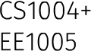
EE3033 Digital Signal Processing |  |  | EE2008
EE2007 Data Communication and Networks
CS3009 Software Engineering
CS2008 Numerical Comp uting
Total
Semester-VI
EE2003 Computer Orgdnization dnd  Architecture |  |  | EE1002
CS2005 Database Systems |  |  | CS2001
CS2006 Operdti ng Systems |  |  | CS2002
MG2002 Engineering Economics
EExxxx MuIti-Disciplinary Engineering
Elective-II
Total
Semester-VII
EE4091 Final Yedr Projec-t I | 3 | 0
EE3033 Digital Design
552001 Technical Communication Skills |  |  | 551005
MG036 Engineering Management
EExxxx Computer Engineering Elective-I
EExxxx Computer Engineering Elective-I I
Total
Semester-VIII
EE4092 Final Year Projec-t II |  |  | EE4091
552013 Entrepreneurship
552007 Tech nicdl and Business Writing |  |  | SS1005
EExxxx Computer Engineering Elective-Ill
EExxxx Computer Engineering Elective -IV
Total

Artificial intelligence and Machine Learning Image Processing dnd Analysis
Network Security and Blockchain System Programming
High Performance Comp uting Control Engineering
Algorith m Design and Analysis Hardware design for DSP and ML
Multi-Disciplinary Engineering Electives (MDEE) Human Computer Interaction (UI/ UX)
Block Chain Technologies and Applications
Neural Networks and Fuzzy Logic Robotics and Automation
Mobile Application/Game Development Virtual Reality
Software Quality Assurance
Instrumentation and Controls VLSI System Design
Data warehousing and Big Data GIS and Remote Sensing


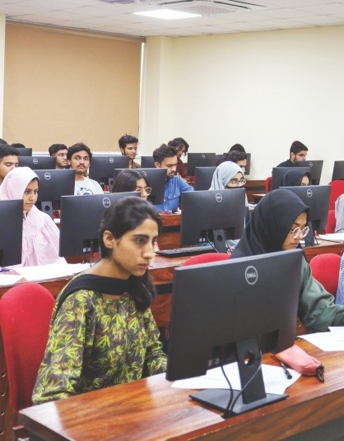

Eligibility for FYP— I: 97 CH
Domain Cr. Hrs
Computing
Computer Engineering
Other Engineering Mdndgement Sciences
NaturaI Sciences
Humdn ities
Total

Prospectus 2025

FAIT- N U C E S
BS Programs in Engineering

Bachelor of Science (Civil Engineering)

Program Vision
T o a c h i e v e n a t i o n d I d n d international recognition through i n n ovati o n i n C ivi l E n gi nee ri ng education, research and community services.

Award of Degree
in the conduct of professional For the award of Bachelor of Science practice. (civil Engineering) degree, a student
- Atta i n i n c re ds i n g leve I of must have
responsibility with interpersonal • Earned at least 140 credits and communicdtion skills. through respective core and

Program Mission
To d eve I o p h i g h ly c o m p ete n t graduates with sound engineering knowledge, social responsibility and lifelong learning skills enabling them to have successful careers in Civil Engineering professions. We achieve
t h i s m i s s i o n t h r o u g h b o t h
u n d e rg ra d u a te a n d g ra d u a te
programs by:

Career Opportunities
A Civi I E n gi nee rin g degree wiII p re p a re yo u fo r w o r k i n I h e construction industry as well as in relevant business, management, and finance sectors. With a solid grasp of s c i e n c e , M a t h e m a I i c s , a n d Engineering knowledge, you will be able to design, create and build sustainable Civil infrastructures to serve society.
elective courses offered in
study plan, AND
  - Obtained a CGPA of at least
2.00

    - Providing vibrant teaching and
ledrning environment to deRiver h i g h q u a t i ty e n g i n e e r i n g education.
    - Ma I EU i n i n§ Stdte -of-th e -d rt c u rric ulu m th at ern ph asizes p racti cal a p p li c at i o n s a n d p rov i d e s o p p o rt u n iti e s fo r hands-on experience.
    - Developing attitude for lifelong learni ng and instilli ng ethical a n d s o c i a I v a I u e s i n o u r gra d u ates th at h el ps th em acquire professional leadership.
    - I d e n t i fy i n g c o n te m p o ra ry iss ues i n C iv i I E n gi n e e ri n g p role ssio n a n d d eve lo p i n g in n ovative solutions through research.
Program Educational Objectives (PEOs)
T h e o b j e c I i v e s o I I h e C i v i I

Tentative Study Plan of Bachelor of Science (Civil Engineering)

Code Title Cr.Hrs Prereq

Semester-I
CV1001 | Civil Engineering Materials | 2
CV1002 | Engineering Drawing | 1
 | Applied Physics and Electro Mechanical Fundamentals | 2
 | Quantitative Reasoning | 3 | 0
 | Functional English | 2 | 0
 | ldeology and Constitution of Pakistan | 2 | 0
 | Application of ICT | 0
SS1021 | Understanding of Holy Quran — 1 | 1 | 0
 | Total | 13 | 5
 | Semester-II
CV1003 | Engineering Surveying | 2
 | Advanced Calculus | 3 | 0
 | Engineering Mechanics | 3
 | Geology for EngineerS | 2 | 0
SS1007 | Islamic Studies/ Ethics | 2 | 0
 | Expository Writing | 2 | 0
 | Pakistan Studies | 2 | 0
SS1022 | Understanding of Holy Quran — II |  | 0
SS1019 | Understanding of Sirat-un-Nabi | NC

Engineering program are to produce |  |  |  | Total | 17 | 2
graduates who will: |  |  | Semester-III
- S u c c e s s f u I I y e n g a g e i n | CV2001 | Advanced Engineering Surveying |  |  | 2 |  | 1 | CV1003
contemporary Civil Engineering |  | Fluid Mechanics |  |  | 2 |  | 1
p ra ctice to solve real-wo rid | CV2005 | Mechanics of Solids-I |  |  | 2 |  | 1 | NS1004
problems. |  | Occupational Health and Safety |  |  | 1 |  | 0
- Purs ue p rofessio n al growth |  | Entrepreneurship |  |  | 2 |  | 0


    - Maintain high ethical standards
th rough co nti nu ous | learni ng | CS1003 | Computer Programming | 1 | 2
andexperience. |  |  | Applied Mathematics | 3 | 0 Advanced  Cafcu dus

Prospectus 2025
Total 13 5

FAST—NUCES

Tentative Study Plan of Bachelor of Science (Civil Engineering)

BS Programs in Engineering

*Arts and Humanities Electives
German Lan ua e
Elementary Chinese Ld ngudge Engineering Ethics
Philosophy
**Social Science Electives
Sociology
Engineering Economics Engineering Law
Eligibility for FYP—I: 100 CH

Domain | Cr. Hrs
Engineer ing | 96
NaturalScience | 15
Humanities, Management Sciences | 19
Computer dnd information sciences | 10
Total 140





CV4010 Design of Structures 1
Code Title Cr.Hrs Prereq
Semester-IV
CV2006 | Structural Analysis-I | 3 |  |  | 0 |  | NS1004
CV2009 | Civil Engineering Graphics and Construction | 1 |  |  | 2 |  | CV1002
CV20â 0 | Quantity and Cost Estimation
MT2007 | Numerical Analysis | 3 |  |  | 0
552009 | Technical Report Writing and Presentation | 0
 | Social Science Elective** | 2 |  |  | 0
CV2003 | Soil Mechanics | 3  Total 13 |  |  | 5 |  | Geology for  Engineers
Semester-V
CV3001 | Advanced Fluid mechanics | 3 |  |  |  |  | CV2002
CVS002 | Architecture and Town Planning | 2 |  |  | 0
CV3002 | Reinforced Concrete Design -I | 3 |  |  | 1 |  | CV2005
 | Introduction to Machine Learning |  |  |  |  |  | Application  DUCT
 | Geo Informatics — Lab
 | Highway and Traffic Engineering |  |  | 2 |  |  | CV2001
 | Geotechnical Engineering |  |  | 2 |  | 1 | CV2003
 |  | Total | 12 |  | 6
 | Semester-VI
CV4005 | Steel Structures |  |  | 3 |  | 0 | CV2005
CV3008 | Str uctura I Ana lysis- II |  |  | 3 |  | 0 | CV2006
CV3006 | Environmental Engg. — I |  |  | 2 |  | 0 | CV2002
CV3007 | Mechanics of Solids-II |  |  | 2 |  | 1 | CV2001
 | Foundation Engineering |  |  | 2 |  | 0 | CV2003
 | Hyd rofogy and Water Management |  |  | 2 |  | 1 | CV2002
 | Civics and Community Engagement |  |  | 2 |  | 0
 | Comm unity Service |  |  |  |  | 0
 | Internship (6-8 weeks) mandatory and qualifying |  |  |  |  | 0
 |  | Total |  | 16 |  | 2
 | Semester-VII
CV4003 | Reinforced Concrete Design - II |  |  | 3 |  |  | CV3002
CV4001 | Environmental Engg— II |  |  | 2 |  |  | CV3006
CV4008 | Fundamentafs of Dynam ics and its Applications |  |  | 2 |  |  | CV2006
 | Arts and Humanities Efestive - I*
CV4009 | Hyd rau lie Engineering |  |  | 2 |  |  | CV2002
MG3007 | Construction Engineering and Management
CV4091 | Final Year Design Project — I |  |  | 0 |  | 3
 |  | Total |  | 11 |  | 7
 | Semester-VIII
 |  |  |  |  |  |  | CV4005,
 |  |  |  |  |  |  | CV3002
CVS011 | Ir rigation and Drainage Engineering |  | 2 |  |  |  | CV3009
 | Arts and Humanities Efestive - II*
 | Bui Id ing Information Modeling Lab
CV4004 | Transportation Planning and Engineering |  | 3 |  |  |  | CV2001
CV4092 | Final Year Design Project — II |  |  |  | 3 |  | CV4091
 |  | Total | 7 |  | 6

Prospectus 2025

F A 5 T- N U C E S

Program Mission
BS Programs in Engineering

Bachelor of Science (Electrical Engineering)

Career Opportunities Award of Degree


The mission of School of Electrical
Engineering is to
    - Develop nurturing environment f o r d e I i v e r i n g q u a l i t y Engineering Education through discovery and innovdtion.
    - S h o w c o m m i t m e n t a n d d e d i c ati o n to te a c h i n g by develop i ng state of th e art curriculum, ground in scientific, m ath em ati cal and te ch n i cal k n owled ge th at em pha sizes p ra cti c al a p p I i cati o n a n d p rov i d e s o p p o rt u n it i e s fo r hands-on experience.
    - lncu tcate lifelong learning and instill ethical and social values in our graduates that helps them acquire professional leadership.
    - Act as centre of excellence to identify the problems of national i n d u s t ry a n d t o d e v e I o p innovative solutions.
Program Educational Objectives
    - PEO-1 Creativity: Apply cutting-edge engineering practices to develop sustainable solutions fo r c o m p I e x e n g i n e e r i n g p r o b I e m s u n d e r I i m i t e d resources
    - P E 0 -2 C o n d u c t: U p h o I d responsible, professional, and e t h i c a I c o n d u c t w i t h interpersonal skills
    - PEO-3 Leadership: Emerge as team ledders in their domain of expertise and in activities that support service and economic develo p ment, N dtion dfly and throughout the world
    - PE 0 -4 Ve rs dt i I ity: P ra cti c e electrical engineering in a broad r a n g e o f i n d u s t r i e s i n a m ulticultural environment and a d a p t I o e m b r a c e n e w technologies

Prospectus 2025
This versatile degree opens careers For the award of Bachelor of Science in d ifferent areas of Electrical (Electrical Engineering) degree, a Engineering. You could pursue a student must have
c a r e e r i n t e I e c o m i n d u s t r y, • Passed courses totaling at electronics, and power sector or in ie a st 14 0 c re d it h o u rs, embedded system design and incuding%tthose courses software programming. which have been specified

as Core courses.
      - Obtained a CGPA of at least 2.00

Tentative Study Plan-Bachelor of Science (Electrical Engineering)

Code | Title | Cr.Hrs |  | Prereq
Semester-I
CS1009 | Applications of ICT | 2 | 1
MT1001 | Applied Calculus
NS1007 | Applied Physics
ME1001 | Engineering Drawing
551005 | English Language Skills
551007 | Islamic Studies/ Ethics
MG1008 | Occupational Health and Safety
SS1003 | Pakistan Studies
551019 | Understanding of Sirat-un-Nabi
Total
Semester-II
552043 | Civics and Community Engagement
MT1006 | Differential Equations |  |  | MT1001
EL1006 | Engineering Workshop
551013 | Ideology and Constitution of Pakistan
MT1004 | Linear Algebra |  |  | MT1001
EE1001 | Linear Circuit Analysis
CS1011 | Programming for Engineers |  |  | C51009
Total
Semester-III
MT2003 | Complex Variables and Transforms | 3 | 0 | MTB 006
EE2004 | Electrical Network Analysis |  |  | EE1001
EE1004 | Electronic Devices and Circuits |  |  | EE1001
MT2008 | Multivariable Calculus |  |  | MT1006
CS2021 | Object Oriented Data Structures |  |  | CS1011
551021 | Understanding of Holy Quran - I
Total


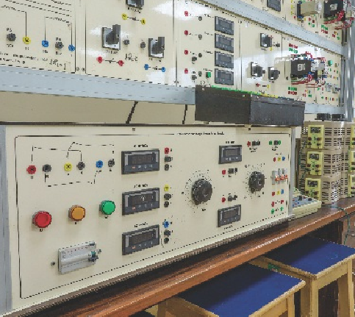
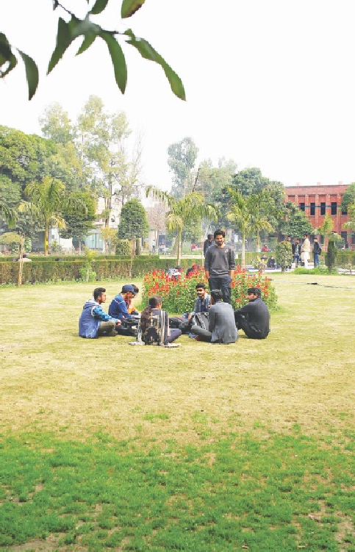
FAST—NUCES

Tentative Study Plan-Bachelor of Science (Electrical Engineering)

Code | Title |  | Cr.Hrs |  | Prereq
Semester-IV
EE2008 | Signa Is and Systems |  | 3 |  | MT2003
EE1005 | Digital Logic Design
MT2005 | Probd bÍlity dnd Stdtistics
EE203 0 | Etectro-Mechanical Systems |  |  |  | NS1002,  EE2004
55022 | U nderstd nding of Qurdn — II
EExxxx | Multi-Discip finary Engineering Elective
Total
Semester-V
EE3003 | And toque dnd DiÿÎtdl Communicdtion |  |  |  | EE201J,  EE2008
EE3005 | Efectr0 mdÇnetic Theory |  |  |  | MT2008
EE3002 | Microprocessor Interfdcing  Progrdmm ing | d nd |  |  | CSS 004,  EE1005
552001 | Tech nical Communication Skiffs |  |  |  | 551005
EExxxx | Depth Core I
Total
Semester-VI
MG2002 | Engineering Economies
EE3004 | Feed bdck Control Systems |  |  |  | EE2008
EE2038 | Power Distri butio n and UtÎlizatiOÜ
EExxxx | Depth Core Il
EExxxx | Depth Efective III
Total
Semester-VII
EE4091 | Final Year Project — I
SS2007 | Tech nical and Business Writing |  |  |  | SS3 005
MG3036 | Engineering Management
EExxxx | Depth Efective IV
EExxxx | Flexib te Elective l
Total
Semester-VIII
EE4092 | Final Year Project — Il |  |  |  | EE4094
SS2043 | Entrepreneurship
EExxxx | Depth Efective V
EExxxx | Flexible Efective Il
EExxxx | Flexible Efective III
Total
BS Programs in Engineering

Eryibifity for FYP—I: 101 CH

Domain |  | Cr.Hrs
computing
Electricdl Engineering |  | 82
Other Engi neen ng |  | 5
Management Sciences |  | 6
N dtU Fdî Sciences |  | 18
Humdnities |  | 18
 | Total | 140

Prospectus 2025

FAST—NUCES

Specialization Streams OPered
Bachelor of Science (Electrical Engineering)
3+J
3+J

3+1
3+J
3+0
3+1
3+0
EE 3024 Power Electronics
EE 2020 Instrumentation and Measurement
EE 3031 Digital Signal Processing
EE 3009 VLSI Design
EE 3031 Introduction to IOT
EE 4026 Industridl Process Control EE 4028 DİĘİtdl Control System
3+1
Electronics
EE 2024 Electronic Circuit Design
3+J
3+J
3*0
3+0
3+J
EE 3009 VLSI Design
EE 3033 Digital Design
IO 3031 Introduction to IOT EE 3006 Embedded System
EE 2012 COmputer Orgdnizdtion dnd Architecture
EE 4024 Introduction to Robotics EE 40s9 Network Security and Blockchdin
EE 4037 Applied Machine Learning
3+1
3+J
3+1
Computer Engineering
EE 3017 Data Communication and
Networks
CS 2020 Operating Systems
CS 2013 Fundamentals of Database
Breadth Core —I
BS Programs in Engineering


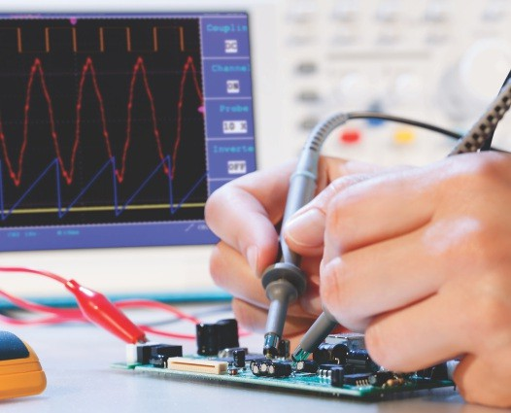
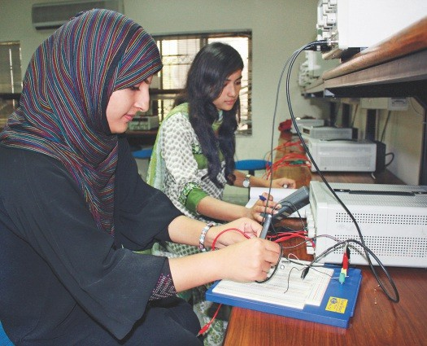
Electric Vehicles
Breadth Core— I
EE 4030 Power Distribution and Utilization
EE 4031 Power System Analysis EE 3024 Power Electronics
EE 3027 Introduction to IOT EE 4033 Power Generdtion
EE 4034 Power System Protection EE 4035 Renewd ble Energy Systems
EE 4089 Electric Power Trdnsmission EE 4036 Power System Operdtion dnd Control
EE XXXX Advanced Electrical Machines
3+1
Breadth Core— II Depth Electives
3+1
3+1
3+0
3+0
3+1
3+1
3+1
3+1
3+1
3+1
EE 4090 lndustridl Automation
3+1
3+J

3+0

Breadth Core— II Depth Electives

Prospectus 2025


FAST—NUCES MS Programs in Engineering
Degree
Engineering
Master of Science (Civil Engineering)

MS Admission Test, Eligibility and Selection Criteria

'

Eligibility 1 | Bachelor of Science (Civil Engineering) % nimum 60% marks or CGPA dt tedst  or equivalent degree from a recognized 2.00 on a scale of 400  University dfter 16 yedrs of educdtion

Selection Criteria | 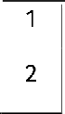  2 | Weightdge of Ad missionTest md rks | 50%
 |  | Weightdge of pdst dcddemic record (Bachelor) | 50%
Degree Master of Science (Electrical Engineering)

Admission Applicdnt must select only one out of the Test three ad mission test options | FAST— NUCES
 | GRE Generdl
NTS GAT-A Generdl

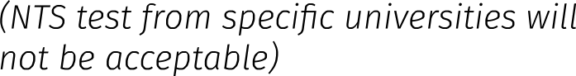

Eligibility 1 | Bachelor of Science (Electrical,  Telecommunications, or Computer Minimum 60% marks or CGPA of at least  Engineering, etc.) or equivdlent degree 2.00 on a scale of 4.00  from a recognized University after 16  years of education

Selection Criteria | 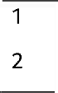  1  2 | Weightdge of Ad mission Test md rks | 50%
 |  | Weightdge of past academic record (Bdchelor) | 50%
NOTE: All documents/transcripts wiII be checked at the ti me of ad m ission. Any incorrect/fdlse information submitted by the applicant or any attempt to hide information will lead to d isqualification of the candidate for ad mission.
 |  |  |  |  |  | FAST— NUCES
‘ ssion |  | ‘d m | yo |  | ne out of the | GRE General
e ' | ::%’ee | t sut neeet |  | pni n |  | NTS GAT-A Generdl
 |  |  |  |  |  | (NTS test from specific universities will
 |  |  |  |  |  | not de acceptable)

Prospectus 2025

FAST—NUCES

Program Mission
To d eve I o p h i gh ly co m p ete n t g r a d u a t e s w i t h a d v a n c e d engineering knowledge and research s ki lls req u ired for p rofessi on al excelle n ce and socio-eco n o m ic development.

Program Objectives (PE0s)
- To en able the gradu ates to s u c c e s s I u I I y e n g a g e i n multidisciplinary civil
e n g i n e e r i n g p r a c t i c e t o contribute to socio-economic development.
- To develop the ability to lead a te a m a s w e I I a s b e i n g a successful team member for life-
MS Programs in Engineering

Master of Science (Civil Engineering)

Award of Degree
I o n g le a r n i n g a n d c a r r i e r For the award of Master of Science development. (Civil Engineering) d egree, a student
- To e n d b I e g r d d u d t e s t o ShdII hdve
contribute to civil engineering • Completed 30 credit hours t h r o u g h r e s e d r c h d n d ds per study pldn AND innovdtions • Obtdined d CGPA Of dt ledst
Areas of Specialization 250
Master of Science (Civil Engineering) Program offers courses and research wo r I‹ i n th e fo how in g a re as of specializations.
- StructuratEngineering
- Hydraulics and Water Recourses Engineering
- Geotechnical Engineering
- Transportation Engineering
- Construction Management




Tentative Study Plan-Master of Science (Civil Engineering)

Research-Based Coursework/Project-Based**
MS Civil Engineering
Courses Cr. Hrs. Courses Cr. Hrs.
Core Courses |  | 3 | 9 | 4 | â 2
Elective (Sp9CldlİZdtion) Courses |  | 4 | 12 | 5 | 15
Elective Course |  | 1 | 3 | 1 | 3
CV5091 MS Thesis— I* |  | 1 | 3 | NA
CV5092 MS Thesis— II |  | 1 | 3 | NA
 | Total Cr. Hrs.: |  | 30 |  | 30
  - MS Thesis — I registration requires completion of 15 credit hours (including Research Methodology) AND a minimum
CGPA of 2.50.
•• Subjected to the approval of Departmental Graduate Studies Committee (DGSC).
Core Courses
CV 5000 | Advanced Structurdl Andlysis | CV 5094 | Advdnced Soil Mdchi ne
CV 5001 | Probab i City and Statistical Methods | CV 5099 | Optimization Techniques
CV 5003 | Foundation Engineering | CV 503 2 | Forensic Engineering
CV 5011 | Finite Element Analysis | CV 503 4 | Principles and techniques of Ground Improvement
CV 5014 | Transportation Plann i ng | CV 503 6 | Geotechnical Engineering of Embankment Dams
CV 5015 | Hydraulic Structures | CV 53 05 | Innovative Civil Engineering Materidl
CV 5017 | Pãvement AndlysiS dnd Design | CV 53 09 | Edrthqudke Engineering
CV 502a | Advd need 0 pen Chdnnel Hyd rdulics | CV 6008 | Advdnced Engineering Mdthemdtics
CV 5022 Trdns - Bounddry Wdter Issues dnd Wdter CV XXX Repair and Rehabilitation of Structures
DI Ș fOmdcy Frdmework
CV5032 Resedrch Methodology*
*Resedrch Methodology is manddtory for US with thesis.

Prospectus 2025

FAST—NUCES
MS Programs in Engineering

Master of Science (Electrical Engineering)

Program Mission
The p urpose of the Master of Science Program in Electrical Engineering is to attain theoretical and practical depth in one of the areas of interest. The Master of Science (EE) program is stru ctured i n s uch a way as to e n ha n ce th e st u d e n t's c riti ca I thinI‹ing and intuitive abilities using a combination of highly specialized courses and expert supervision. The program aims to produce graduates who will have the abilities and skills to b e e m p I oye d a s p ra ct i c i n g Engineers in fields such as design, research development, testi ng, and man ufacturing, as well as assuming p o s i t i o n s o I ie a d e r s h i p a n d responsibility within organizations.

Program Educational Objectives (PEOs)
- Provide students with advanced learning and application in a d iscipline or sub-d iscipline of E I e c t r i c a I E n g i n e e r i n g . (Application to be added)
- Teaching tools and techniques required for advanced learning, resed rch dFI d d IlCdtion in dny d iscipline or sub-d iscipline of Electricdl Engineering.
- En h d n ce s ki lls su ch d reds ds problem — Solvi ng, mdthP M dtlCdI m o d e li n g, w riti ng d n d o rd p r e s e n t d t i o n , I e d d e r s h i p i nte r reldtion of business with technology and ethiCS d plied to Electricdl Engineering.

Award of Degree
For the award of Master of Science (Electrical Engineering) degree, a student must hdve
  - Pdssed courses totd ti 0§ dt ie d s t 3 0 c r e d i t h o u r s , including Three core courses
  - O btdined d CGPA Of dt ledst
2.50


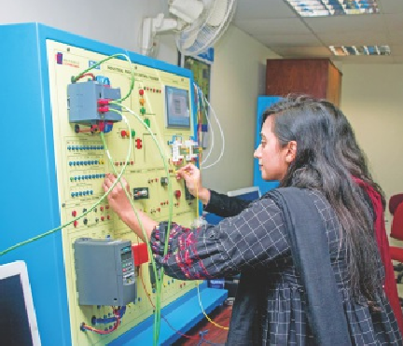

Tentative Study Plan-Master of Science (Electrical Engineering)

MS Civil Engineering | Research-Based  Courses Cr. Hrs. |  | Coursework/ Project-Based**  Courses Cr. Hrs.
Core Courses | 3 | 9 | 4 | J2
Elective (Specialization) Courses | 4 | J2 | 5 | 5
Elective Course | 1 | 3 | 1 | 3
CV5091 MS Thesis— I* | 1 | 3 | NA
CV5092 MS Th esis— 11 | 1 | 3 | NA
Total Cr. Hrs.: |  | 30 |  | 30
    - MS Thesis — I registration requires completion of 15 credit hours (including Research Methodology) AND d minimum CGPA Of 2.50.
•• Subjected to the dpprovdl of Departmental Grddudte Studies Committee (DGSC).
Core/Elective Courses

 | Core Courses |  | Elective Courses
EE 5035 | Engineering Optimization | A15003 | Advanced Machine Learning
EE 5049 | Computational Statistics | DS 5006 | Deep Learning
EE 5043 | Adv. Embedded Systems dnd  Networks | CS 5042 | Advdnced Network Security
l0503J | Internet of Things | CS 5024  EE5041 | Advdnced Computer Networks  Advdnced Control Systems
 |  | \/—XXXX | Any other elective from CS / EE
 |  | EE5011 | Resed rch Meth od ology*
*Resed rch Methodology is mdnddtory for MS with thesis.

Prospectus 2025

